Horizontal Plane
# Source: AI Source: Provided by: [Data Path: Persons Table -> ID Column: 1, Name_En Column: Motasem Essam] -> From: [ChatGPT] on [7/25/2026]
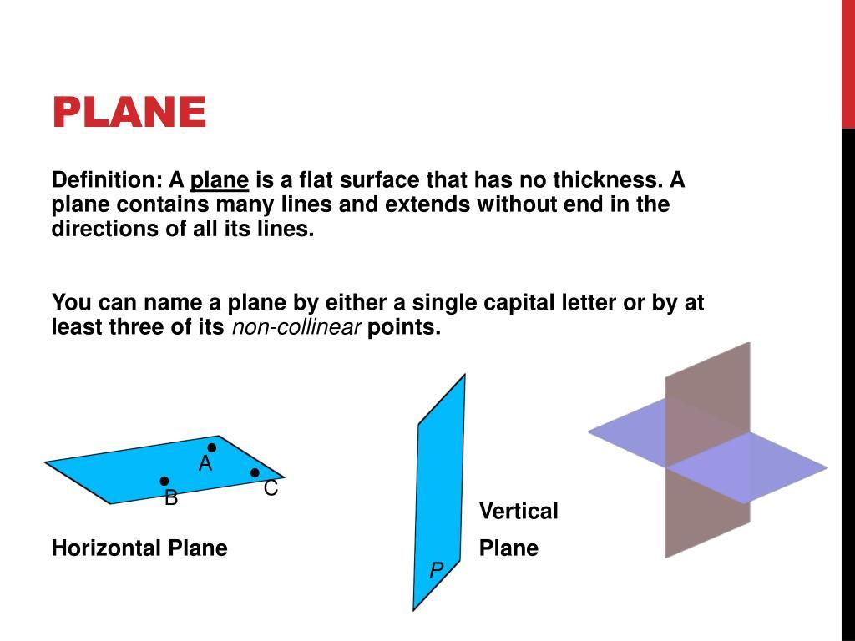
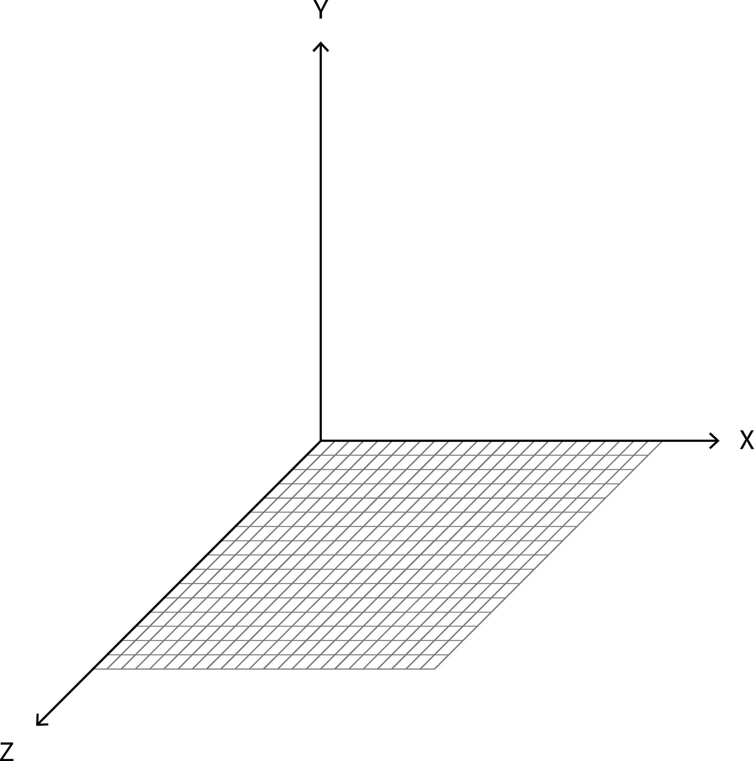
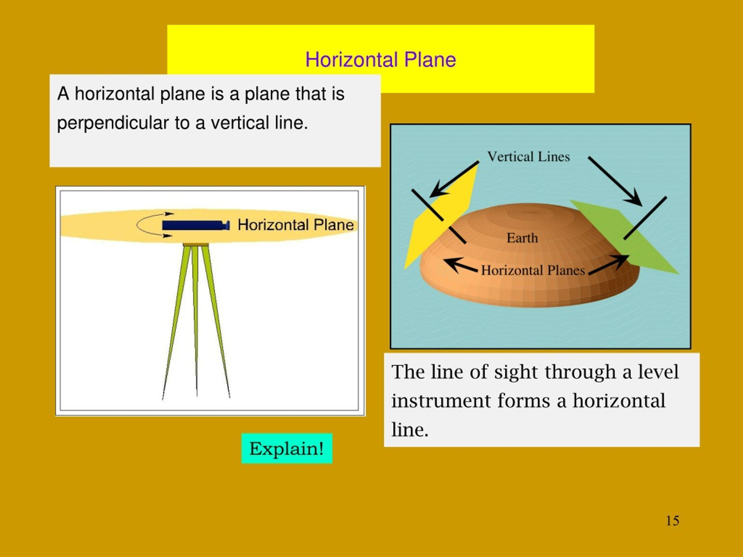
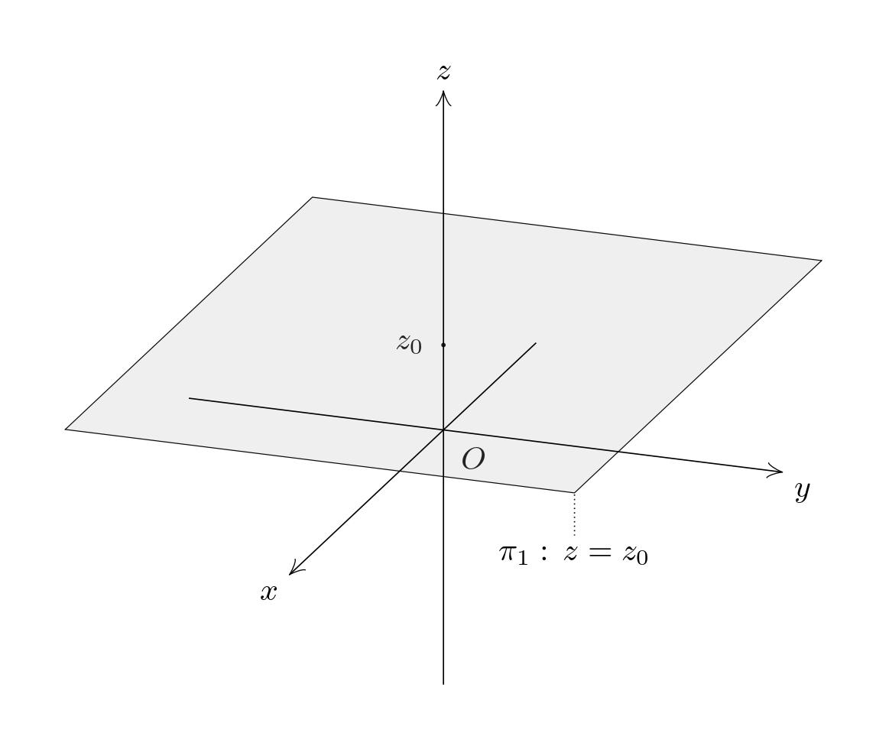

Definition
# Source: AI Source: Provided by: [Data Path: Persons Table -> ID Column: 1, Name_En Column: Motasem Essam] -> From: [ChatGPT] on [7/25/2026]
A Horizontal Plane is a plane that is parallel to the horizon and perpendicular to the direction of gravity. It extends infinitely in all horizontal directions and has no upward or downward inclination.
In three-dimensional coordinate geometry, a horizontal plane is typically represented by an equation of the form:
$$z=c$$
where $c$ is a constant. Every point on the plane has the same vertical ($z$) coordinate.

Characteristics
# Source: AI Source: Provided by: [Data Path: Persons Table -> ID Column: 1, Name_En Column: Motasem Essam] -> From: [ChatGPT] on [7/25/2026]
A horizontal plane:
- Is flat and level.
- Is parallel to the horizon.
- Is perpendicular to the direction of gravity.
- Extends infinitely in length and width.
- Has zero slope in every horizontal direction.
- Contains infinitely many points and lines.

Illustration
# Source: AI Source: Provided by: [Data Path: Persons Table -> ID Column: 1, Name_En Column: Motasem Essam] -> From: [ChatGPT] on [7/25/2026]
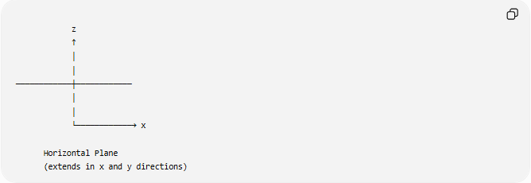

z
↑
│
│
────────────┼────────────
│
│
└────────────→ x

Horizontal Plane
(extends in x and y directions)

Mathematical Representation
# Source: AI Source: Provided by: [Data Path: Persons Table -> ID Column: 1, Name_En Column: Motasem Essam] -> From: [ChatGPT] on [7/25/2026]
General Form
A horizontal plane is represented by:
$$z=c$$
where:
- $z$ = vertical coordinate
- $c$ = constant height
Examples:
$$z=0$$
(the $xy$-plane)
$$z=5$$
(a horizontal plane 5 units above the $xy$-plane)

Standard Equation
The $xy$-plane is the most common horizontal plane:
$$z=0$$

Position in the Coordinate System
# Source: AI Source: Provided by: [Data Path: Persons Table -> ID Column: 1, Name_En Column: Motasem Essam] -> From: [ChatGPT] on [7/25/2026]
In a three-dimensional Cartesian coordinate system:
- $x$-axis: horizontal
- $y$-axis: horizontal
- $z$-axis: vertical
The horizontal plane is parallel to both the $x$-axis and the $y$-axis.
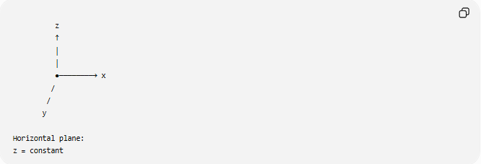
z
↑
│
│
●────────→ x
/
/
y

Horizontal plane:
z = constant

Examples
# Source: AI Source: Provided by: [Data Path: Persons Table -> ID Column: 1, Name_En Column: Motasem Essam] -> From: [ChatGPT] on [7/25/2026]
Example 1
The equation:
$$z=0$$
represents the horizontal coordinate plane ($xy$-plane).

Example 2
The equation:
$$z=8$$
represents a horizontal plane located 8 units above the $xy$-plane.

Example 3
Determine whether:
$$z=-3$$
is horizontal.
Since the value of $z$ is constant:
$$\boxed{\text{It is a horizontal plane.}}$$

Properties
# Source: AI Source: Provided by: [Data Path: Persons Table -> ID Column: 1, Name_En Column: Motasem Essam] -> From: [ChatGPT] on [7/25/2026]
1. Constant Height
Every point on the plane has the same height:
$$z=c$$

2. Parallel to the Horizon
The plane remains level regardless of its position.

3. Perpendicular to the Vertical Axis
The normal vector of a horizontal plane is parallel to the $z$-axis.
For
$$z=c$$
the normal vector is:
$$\left\langle 0,0,1\right\rangle$$

4. Infinite Extent
The plane has no boundaries.

Real-World Examples
# Source: AI Source: Provided by: [Data Path: Persons Table -> ID Column: 1, Name_En Column: Motasem Essam] -> From: [ChatGPT] on [7/25/2026]
Horizontal planes include:
- Calm water surfaces.
- Floors.
- Tables.
- Ceilings.
- Flat roads.
- Building slabs.
- Land survey reference planes.
- Sea level reference surfaces.

Applications
# Source: AI Source: Provided by: [Data Path: Persons Table -> ID Column: 1, Name_En Column: Motasem Essam] -> From: [ChatGPT] on [7/25/2026]
Horizontal planes are used in:
- Plane Geometry
- Coordinate Geometry
- Analytic Geometry
- Engineering
- Architecture
- Construction
- Surveying
- Navigation
- CAD (Computer-Aided Design)
- Computer Graphics
- Robotics
- Physics

Advantages
# Source: AI Source: Provided by: [Data Path: Persons Table -> ID Column: 1, Name_En Column: Motasem Essam] -> From: [ChatGPT] on [7/25/2026]
Studying horizontal planes helps to:
- Describe elevation.
- Model flat surfaces.
- Analyze three-dimensional objects.
- Define coordinate systems.
- Solve geometric and engineering problems.

Limitations
# Source: AI Source: Provided by: [Data Path: Persons Table -> ID Column: 1, Name_En Column: Motasem Essam] -> From: [ChatGPT] on [7/25/2026]
A horizontal plane:
- Must remain level.
- Cannot have any inclination.
- Is different from inclined or vertical planes.
- Is represented by a constant (z)-value only.

Comparison with Other Plane Types
# Source: AI Source: Provided by: [Data Path: Persons Table -> ID Column: 1, Name_En Column: Motasem Essam] -> From: [ChatGPT] on [7/25/2026]
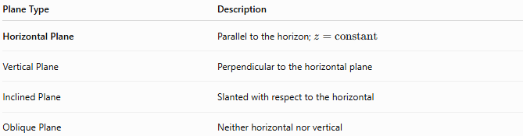
Plane Type | Description
Horizontal Plane | Parallel to the horizon; (z=\text{constant})
Vertical Plane | Perpendicular to the horizontal plane
Inclined Plane | Slanted with respect to the horizontal
Oblique Plane | Neither horizontal nor vertical

Key Points
# Source: AI Source: Provided by: [Data Path: Persons Table -> ID Column: 1, Name_En Column: Motasem Essam] -> From: [ChatGPT] on [7/25/2026]
- A Horizontal Plane is level and parallel to the horizon.
- Standard equation:
$$z=c$$
- The $xy$-plane is:
$$z=0$$
- All points on the plane share the same vertical coordinate.
- Horizontal planes are fundamental in geometry, engineering, surveying, and computer graphics.

Conclusion
# Source: AI Source: Provided by: [Data Path: Persons Table -> ID Column: 1, Name_En Column: Motasem Essam] -> From: [ChatGPT] on [7/25/2026]
A Horizontal Plane is a flat, level plane that is parallel to the horizon and perpendicular to the direction of gravity. In coordinate geometry, it is represented by an equation of the form $z=c$, meaning every point on the plane has the same elevation. Horizontal planes are fundamental in analytic geometry, engineering, architecture, construction, surveying, navigation, CAD, robotics, physics, and computer graphics, where they provide a standard reference for describing level surfaces and spatial relationships.

